

Capstone Project Report
Report 4 – Software Design Document

– HoChiMinh, October 2026 –

Table of Contents
I. Record of Changes 3
II. Software Design Document 4
1. System Design 4
1.1 System Architecture 4
1.2 Package Diagram 4
2. Database Design 4
3. Detailed Design 4
3.1 Authentication & Account Management 4
3.2 Tray Rental & Resource Reservation 4
3.3 Online Payment Processing via SePay VietQR 4
3.4 Rented Tray Monitoring & IoT Telemetry Ingestion 4
3.5 IoT Threshold Rule Engine & Manual Device Control 4
3.6 Farm Operations, Growing Cycles & Order Fulfillment 4

I. Record of Changes
Date | A*  M, D | In charge | Change Description
28/09/2026 | A | Phan Dieu Linh | Designed and documented the overall High-Level System Architecture layout.
29/09/2026 | A | Ha Viet Thanh | Modeled the UML Back-end Package Diagram for the C# .NET solution.
30/09/2026 | A | Ha Viet Thanh | Formulated the Database Design schema and Entity-Relationship Diagram (ERD).
30/09/2026 | A | Phan Dieu Linh | Documented comprehensive Database Table Descriptions and column specifications.
01/10/2026 | A | Phan Dieu Linh | Documented Table Descriptions, Class Specs, and Sequence Diagrams for Features 1-3
02/10/2026 | A | Phan Dieu Linh | Documented Table Descriptions, Class Specs, and Sequence Diagrams for Features 4-6
02/10/2026 | A | Ha Viet Thanh | Modeled the IoT Package Diagram covering hardware nodes and MQTT messaging layers.
22/10/2026 | M | Phan Dieu Linh | Updated Database Design.
*A - Added M - Modified D - Deleted

II. Software Design Document

1. System Design

1.1 System Architecture
The Smart Farm Microgreens Management System adopts a modern multi-tiered hybrid architecture that integrates microservices, client applications, cloud endpoints, asynchronous message brokers, relational database storage, and physical IoT embedded microcontrollers.
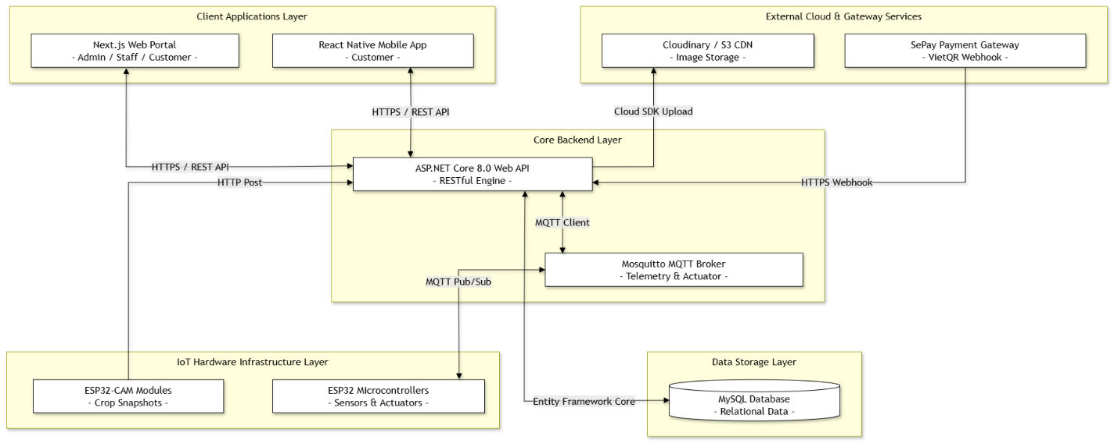
Detailed System Components Explanation:

1.1.1 Client Applications Layer:
React Native Mobile App: Dedicated exclusively to end-customers for browsing seed catalogs, subscribing to tray rentals, ordering agricultural supplies, monitoring real-time crop parameters, viewing growth progress photos, and receiving push notifications.
Next.js Web Portal: Serves as a unified web application accessible by all user roles:
Customers: Can access desktop dashboards to manage orders, tray rentals, and account settings.
Farm Staff: Utilized for reviewing daily operational care tasks (DailyTasks), confirming task completions, and logging maintenance notes.
System Administrators: Provides full administrative control over farm topology (zones, racks, trays), IoT hardware pin mapping, seed catalog inventory, care schedule SOP templates, and system analytics.

1.1.2 Core Backend Layer:
ASP.NET Core 8.0 Web API: The central application server handling RESTful APIs, JWT authentication, business logic execution, automated care task generation algorithms, threshold breach detection, and commercial order lifecycle management.
Mosquitto MQTT Broker: Facilitates low-latency, real-time asynchronous publish/subscribe messaging between backend services and physical hardware endpoints.

1.1.3 IoT Hardware Infrastructure Layer
ESP32 Microcontrollers: Embedded nodes deployed on physical farm racks. These microcontrollers continuously measure soil moisture, ambient temperature, air humidity, and light levels, while driving relays for irrigation pumps, LED grow lights, and ventilation fans.
ESP32-CAM Modules: Specialized camera hardware placed above cultivation trays that periodically capture crop growth photos and transmit binary payloads to the backend API.

1.1.4 Data Storage Layer:
MySQL Database: Relational database storing persistent entities, including user credentials, orders, supply inventory, farm layout mapping, configuration thresholds, and historical sensor telemetry logs.

1.1.5 External Cloud & Gateway Services:
SePay Payment Gateway: Handles VietQR bank transfer reconciliations and dispatches immediate notification webhooks to the backend upon successful payment settlement.
Cloudinary / S3 CDN: Content Delivery Network providing secure hosting and optimized image rendering for crop snapshot photos uploaded by the system.

1.2 Package Diagram

1.2.1 Back-end Package Diagram

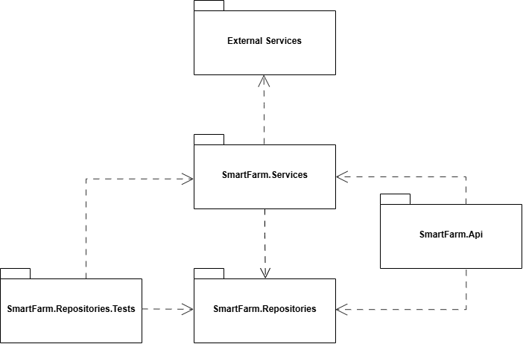
Package Descriptions
No | Package | Description
01 | SmartFarm.Api | Serves as the presentation layer, hosting RESTful API endpoints, HTTP Controllers, CORS configurations, JWT Authentication/Authorization middlewares, Swagger UI, Dependency Injection containers, and application startup configs.
02 | SmartFarm.Services | Represents the core business logic layer, handling primary domain workflows (order management, SePay payment verification, crop care schedules, notification processing, and MQTT IoT telemetry routing).
03 | SmartFarm.Repositories | Represents the data access layer, responsible for direct communication with the MySQL database, defining Entity Framework Core models, ApplicationDbContext, CRUD operations, and database transactions.
04 | SmartFarm.Repositories.Tests | Serves as the automated testing layer, holding unit and integration tests to validate data access integrity, repository queries, and database transaction accuracy
05 | External Services | Encapsulates external IoT communication configurations and cloud service protocols, including Mosquitto MQTT Broker environment configs, SePay VietQR payment webhook gateway, and Cloudinary CDN storage.

1.2.2 Web Application Package Diagram
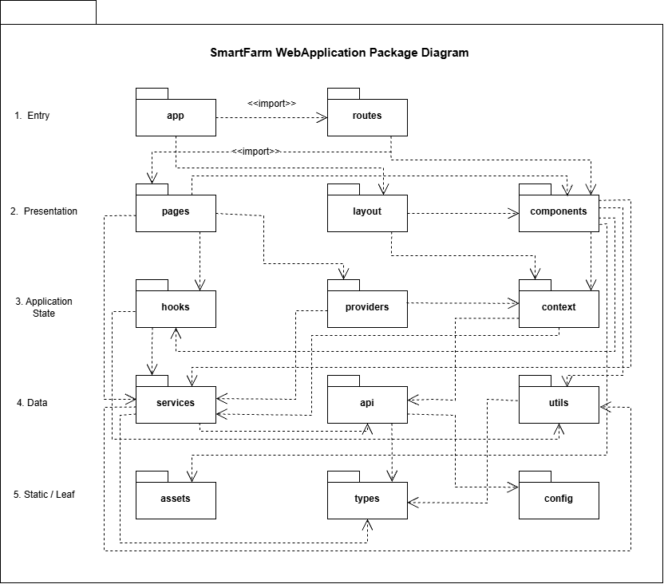
Package Descriptions
No | Package | Description
01 | app | Provides the main entry point of the SmartFarm Web Application and initializes the application structure, global styles, and shared providers.
02 | routes | Defines URL paths and maps each route to the appropriate page, layout, and access-control rules.
03 | pages | Contains page-level user interfaces for customer, staff, and administrator functions.
04 | layouts | Defines reusable page structures such as headers, sidebars, navigation menus, footers, and role-specific shells.
05 | components | Contains reusable presentation components used to build pages and implement user interactions.
06 | hooks | Provides reusable React hooks for component behavior, state access, data retrieval, and UI-related logic.
07 | providers | Initializes and supplies shared application state and services to descendant components.
08 | contexts | Defines shared React contexts for authentication, shopping cart, user sessions, and feature-specific state.
09 | services | Implements application operations and coordinates communication between the user interface, API client, and business data.
10 | api-client | Handles HTTP communication with the backend API, including request configuration, authentication tokens, responses, and errors.
11 | utils | Contains reusable utility functions such as formatting, validation, conversion, calculation, and data-processing helpers.
12 | assets | Stores static resources used by the Web Application, including images, icons, fonts, and other public files.
13 | types | Defines shared TypeScript types, interfaces, enums, and data contracts used across the application.
14 | config | Contains application configuration such as API endpoints, environment settings, feature options, and shared constants.

1.2.3 Mobile Application Package Diagram
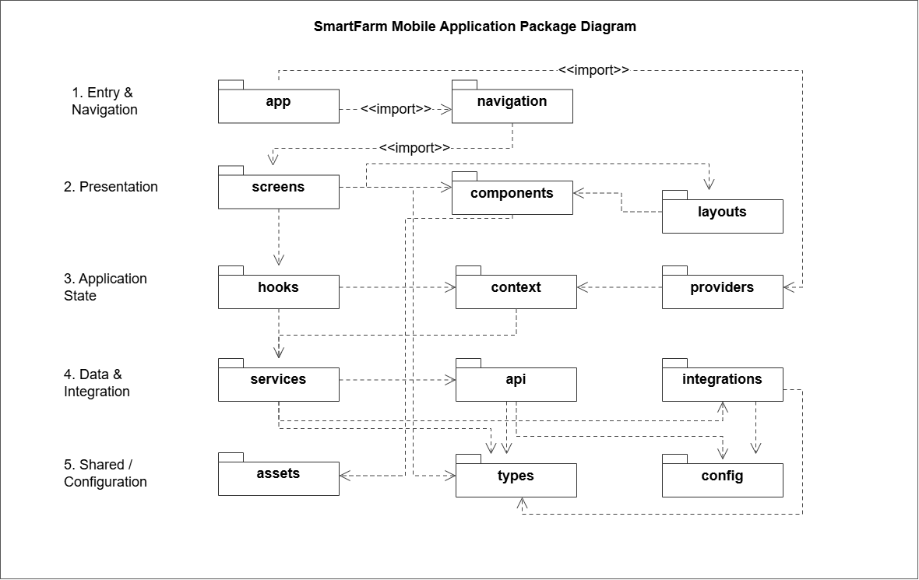
Package Descriptions
No | Package | Description
01 | app | Main entry point of the SmartFarm Mobile Application, responsible for initializing the application, loading global providers, and setting up the navigation system.
02 | navigation | Manages navigation between application screens, including authentication flows, main tabs, and protected routes for authenticated users.
03 | screens | Contains user interface screens for login, registration, tray rental, seed purchasing, payment, tray monitoring, order tracking, and delivery scheduling.
04 | components | Provides reusable UI components such as buttons, input fields, cards, modals, loading indicators, and monitoring widgets used across multiple screens.
05 | layouts | Defines shared screen layouts and common interface structures to maintain consistent presentation throughout the mobile application.
06 | hooks | Contains custom React hooks for managing reusable application logic, including authentication state, API requests, tray monitoring, and user interactions.
07 | context | Defines React Context objects for sharing global application state, such as authentication information and user preferences, across components.
08 | providers | Wraps the application with global state providers and supplies shared context values to screens and components.
09 | services | Implements application-level business operations, including tray rental, seed purchasing, order management, payment status checking, and environmental monitoring.
10 | api | Handles communication with the SmartFarm Backend REST API, including HTTP requests, authentication tokens, response processing, and error handling.
11 | integrations | Manages integration with external mobile services, particularly Firebase Cloud Messaging for push notifications and Firebase Authentication if enabled.
12 | assets | Stores static application resources, including images, icons, fonts, and other visual assets used in the mobile interface.
13 | types | Defines shared TypeScript interfaces, types, and data models for users, trays, seed varieties, orders, payments, sensor readings, and API responses.
14 | config | Stores application configuration settings, including API base URLs, environment variables, Firebase settings, and other integration parameters.

1.2.4 IoT Package Diagram
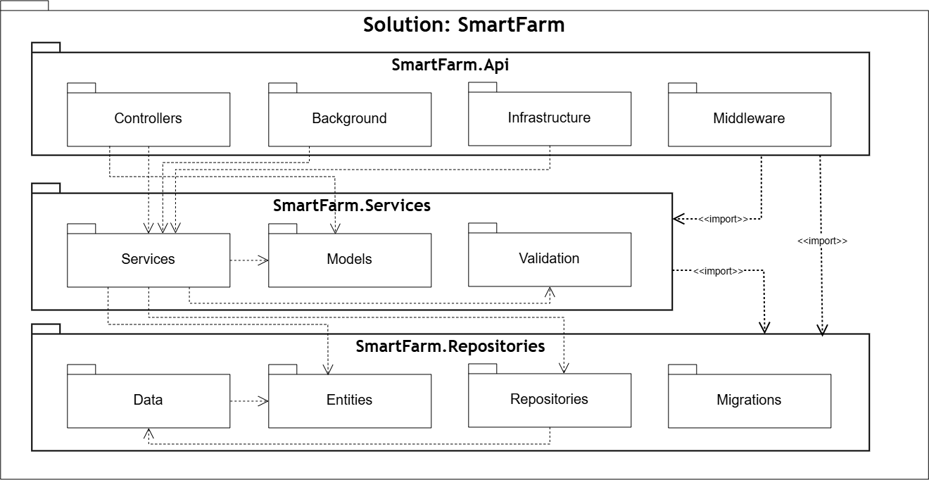
Package Descriptions
No | Package | Description
01 | SmartFarm.Api | Top-level Presentation project hosting REST API endpoints, background workers, authentication options, and HTTP middleware pipeline.
02 | Controllers | Handles incoming HTTP client requests across cultivation, IoT device management, order fulfillment, and delivery operations.
03 | Background | Runs continuous background hosted services (MqttBackgroundService) for IoT telemetry processing and scheduled automation tasks.
04 | Infrastructure | Configures system infrastructure components, JWT authentication options, and MQTT broker connection handlers.
05 | Middleware | Contains custom HTTP pipeline components for global exception handling and device key hardware authentication (X-Device-Key).
06 | SmartFarm.Services | Business Logic Layer project encapsulating application services, data transfer contracts, and domain business rules.
07 | Services | Implements core application services (CultivationService, IoTManagementService, DeliveryService, MqttService) for business workflows.
08 | Models | Defines Data Transfer Objects (Request/Response DTOs) and standard ApiResponse<T> wrappers for API payload contracts.
09 | Validation | Encapsulates FluentValidation rules to perform input data integrity checks before executing business operations.
10 | SmartFarm.Repositories | Data Access Layer project managing relational database persistence, domain entity definitions, and Unit of Work patterns.
11 | Data | Manages AppDbContext context configuration, EF Core model mappings, and MySQL connection factories.
12 | Entities | Defines domain entity classes (TrayRental, IoTDevice, SensorTelemetry, ActuatorLog, Order, Delivery).
13 | Repositories | Implements IUnitOfWork and generic repository interfaces to coordinate atomic relational database transactions.
14 | Migrations | Maintains versioned EF Core schema migration scripts for automated MySQL database deployments.

2. Database Design
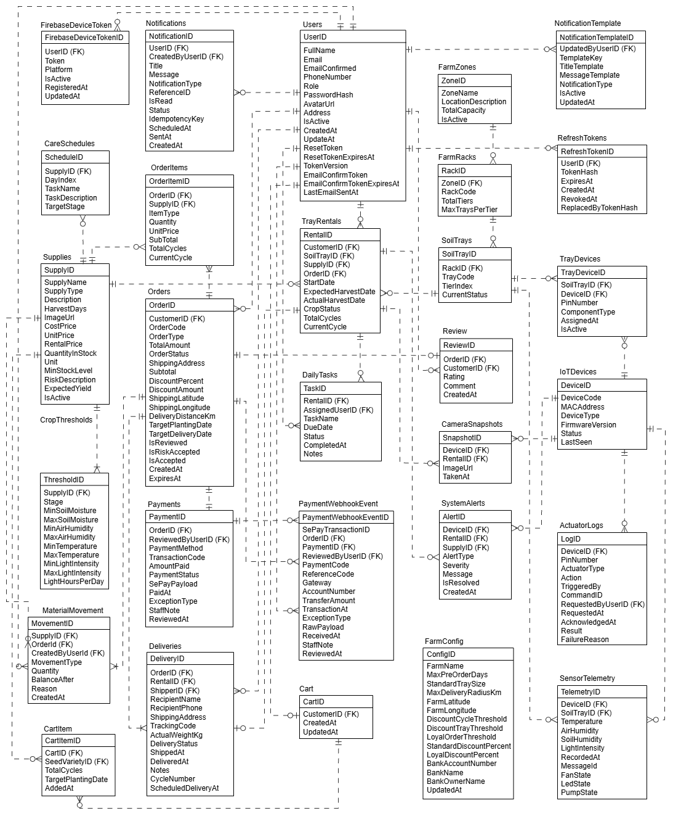
Table Descriptions
No | Table | Description
01 | Users | Stores user account information, authentication details, roles, and profile attributes.  - Primary keys: UserID  - Foreign keys: None
02 | RefreshTokens | Manages JWT refresh tokens for secure session maintenance, rotation, and revocation.  - Primary keys: RefreshTokenID  - Foreign keys: UserID
03 | Notifications | Stores system-generated and event-driven push notifications dispatched to users.  - Primary keys: NotificationID  - Foreign keys: UserID
04 | FarmZones | Defines physical farm areas/zones and their total rack accommodation capacity.  - Primary keys: ZoneID  - Foreign keys: None
05 | FarmRacks | Represents physical farming racks located within specific farm zones.  - Primary keys: RackID  - Foreign keys: ZoneID
06 | SoilTrays | Manages physical microgreen soil cultivation trays placed on rack tiers.  - Primary keys: SoilTrayID  - Foreign keys: RackID
07 | TrayDevices | Maps IoT microcontroller pin configurations to specific soil trays and sensor components.  - Primary keys: TrayDeviceId  - Foreign keys: SoilTrayID, DeviceID
08 | IoTDevices | Registers ESP32 microcontrollers and ESP32-CAM hardware with MAC addresses and firmware status.  - Primary keys: DeviceID  - Foreign keys: None
09 | ActuatorLogs | Logs manual and automated relay execution commands (pumps, lights, fans) over MQTT.  - Primary keys: LogID  - Foreign keys: DeviceID, RequestedByUserID
10 | Supplies | Catalog of agricultural seed varieties, soil substrates, packaging, and retail/rental items.  - Primary keys: SupplyID  - Foreign keys: None
11 | CropThresholds | Defines agronomic environmental parameters (moisture, temperature, light) per growth stage.  - Primary keys: ThresholdID  - Foreign keys: SupplyID
12 | CareSchedules | Stores Standard Operating Procedure (SOP) daily care task templates for each crop type.  - Primary keys: ScheduleID  - Foreign keys: SupplyID
13 | TrayRentals | Tracks active tray rental subscriptions, assigned soil trays, and crop growth lifecycles.  - Primary keys: RentalID  - Foreign keys: CustomerID, SoilTrayID, SupplyID, OrderID
14 | DailyTasks | Schedules daily operational farm tasks assigned to farm staff for active tray rentals.  - Primary keys: TaskID  - Foreign keys: RentalID, AssignedUserID
15 | SensorTelemetry | Stores IoT environmental telemetry data (temperature, humidity, light intensity).  - Primary keys: TelemetryID  - Foreign keys: DeviceID, SoilTrayID
16 | CameraSnapshots | Stores image metadata and Cloudinary URLs captured periodically by ESP32-CAM modules.  - Primary keys: SnapshotID  - Foreign keys: DeviceID, RentalID
17 | SystemAlerts | Records critical hardware failures, offline events, and environmental threshold breach alerts.  - Primary keys: AlertID  - Foreign keys: DeviceID, RentalID
18 | Orders | Manages customer commercial orders for tray rentals, seed packets, and shipping preferences.  - Primary keys: OrderID  - Foreign keys: CustomerID
19 | OrderItems | Holds granular line-item breakdown, quantities, and pricing for each customer order.  - Primary keys: OrderItemID  - Foreign keys: OrderID, SupplyID
20 | Payments | Logs online VietQR/SePay payment transaction payloads, verification codes, and statuses.  - Primary keys: PaymentID  - Foreign keys: OrderID
21 | Deliveries | Tracks harvest logistics, shipping address, external tracking codes, and delivery status.  - Primary keys: DeliveryID  - Foreign keys: OrderID, RentalID, ShipperID
22 | MaterialMovements | Tracks detailed supply inventory changes including stock receipts, operational usage logs, and sales deductions to maintain real-time supply balances.  - Primary keys: MovementID  - Foreign keys: SupplyID, CreatedByUserID
23 | PaymentWebhookEvents | Stores raw incoming bank transfer webhook JSON payloads received from SePay gateway for audit logging, idempotent verification, and payment exception reconciliation.  - Primary keys: EventID  - Foreign keys: PaymentID
24 | NotificationTemplates | Defines reusable notification templates containing dynamic placeholders for system-generated alerts and order status updates.  - Primary keys: TemplateID  - Foreign keys: None
25 | FirebaseDeviceTokens | Registers customer and staff mobile device tokens for dispatches of push notifications via Firebase Cloud Messaging (FCM).  - Primary keys: TokenID  - Foreign keys: UserID
26 | Carts | Maintains active shopping cart sessions for customers selecting tray rental packages or seed products prior to checkout.  - Primary keys: CartID  - Foreign keys: CustomerID
27 | CartItems | Holds individual product line items, selected seed varieties, tray configurations, and quantities within an active customer shopping cart.  - Primary keys: CartItemID  - Foreign keys: CartID, SupplyID
28 | FarmConfigs | Holds global operational configuration parameters including maximum delivery radius (10 km), max pre-order booking limits, VietQR bank account credentials, and automated discount promotion thresholds.  - Primary keys: ConfigID  - Foreign keys: UpdatedByUserID
29 | Reviews | Stores customer satisfaction star ratings (1-5 stars) and feedback text submitted for completed orders, enforcing a strict 1-to-1 relationship per order.  - Primary keys: ReviewID  - Foreign keys: OrderID, CustomerID

3. Detailed Design
This section presents the detailed architectural design of the SmartFarm platform. The system is engineered following a Clean / Layered Architecture pattern consisting of three primary operational layers:
Presentation Layer (API Controllers): Exposes HTTPS RESTful endpoints, handles HTTP request validation, enforces JWT Role-Based Access Control (RBAC), and delegates business operations to the service layer.
Business Logic Layer (Services & Infrastructure): Encapsulates domain logic, data transformation DTOs, security services (JWT Generation, Password Hashing), and external integrations (SMTP Email, Mosquitto MQTT Broker, SePay Webhook).
Data Access Layer (Repositories & Entities): Manages relational data persistence, Entity Framework Core ORM mappings, atomic transaction management via the Unit of Work pattern, and direct database interactions with MySQL.
The detailed design for each core feature includes a high-level Class Diagram, Class Specifications table, and Sequence Diagram(s) illustrating component interactions across these architecture layers.

3.1 Authentication & Account Management
Feature 1 manages the complete lifecycle of user accounts, user identity authentication, Role-Based Access Control (RBAC), and session security. It implements JSON Web Token (JWT) authentication alongside a Token Rotation mechanism (Access Token & Refresh Token), secure password hashing (PasswordHasher), email address confirmation via SMTP (EmailService), and self-service account profile management.

3.1.1 Class Diagram
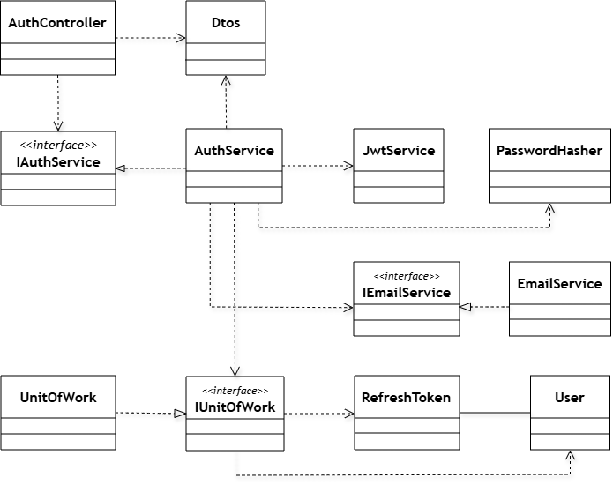
Class Specifications
No | Class / Interface Name | Layer / Type | Description
01 | AuthController | Presentation | Handles incoming HTTP REST API requests for authentication and forwards user actions to IAuthService.
02 | IAuthService | Business Service (Interface) | Defines the abstract service contract for core authentication operations (Registration, Login, Token Refresh, Password Reset).
03 | AuthService | Business Service (Implementation) | Implements core authentication business logic, validating credentials, coordinating token creation, and interacting with data storage.
04 | JwtService | Security Infrastructure | Generates JWT Access Tokens with user claims (UserId, Role, TokenVersion) and computes SHA256 hashed Refresh Tokens.
05 | PasswordHasher | Security Utility | Provides static methods for secure password hashing using ASP.NET Core Identity algorithms and constant-time hash verification.
06 | IEmailService | Communication (Interface) | Declares the contract for sending transactional emails to users.
07 | EmailService | Communication (Implementation) | Implements SMTP email delivery via MailKit/MimeKit to send email confirmation links and password reset OTP tokens.
08 | IUnitOfWork | Data Access (Interface) | Declares the unit of work contract for accessing repositories and committing atomic database transactions.
09 | UnitOfWork | Data Access (Implementation) | Implements transaction management and instantiates repository instances for Users and RefreshTokens.
10 | User | Domain Entity | Represents the Users database table storing credentials, roles, email verification status, and token versions.
11 | RefreshToken | Domain Entity | Represents the RefreshTokens database table tracking hashed tokens, expiration timestamps, and revocation status.
12 | Dtos | Data Transfer Objects | Encapuslates request payloads (RegisterRequest, LoginRequest, etc.) and API response models (UserResponse, LoginResponse).

3.1.2 Sequence Diagram 1: User Registration & Email Confirmation
This sequence diagram illustrates the workflow for registering a new customer account and confirming the email address. When a user submits registration details, the system validates email uniqueness, hashes the password securely, generates a 30-minute confirmation token, persists the user entity in the database via Unit of Work, and dispatches a verification email via SMTP. Upon clicking the email link, the confirmation endpoint verifies the token and updates the user's email confirmation status.
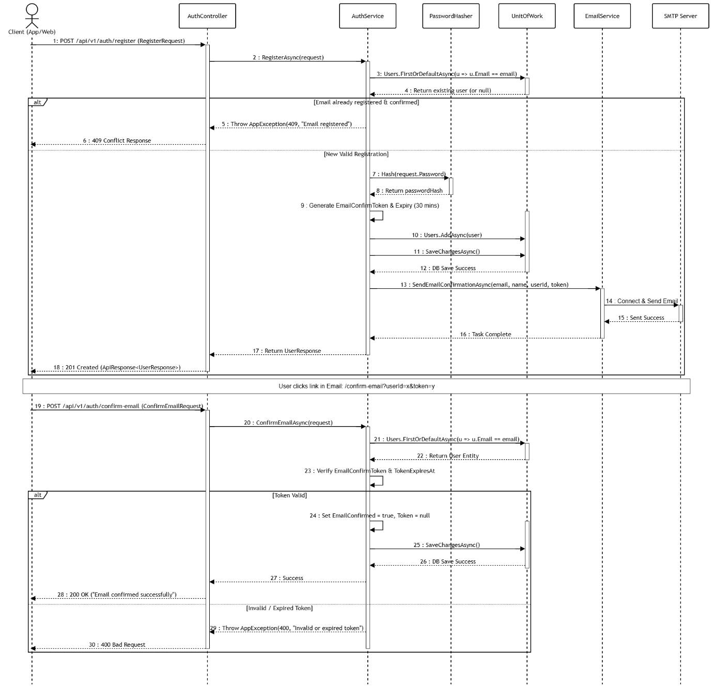

3.1.3 Sequence Diagram 2: User Authentication & Token Refresh
This sequence diagram presents the credential authentication and automated Token Refresh Rotation mechanism. Upon submitting valid credentials, the system verifies the password hash, checks account activation and email confirmation status, and issues a JWT Access Token alongside a hashed Refresh Token. When the Access Token expires, the client invokes the refresh endpoint, triggering token hash verification, old token revocation, and new token pair issuance.
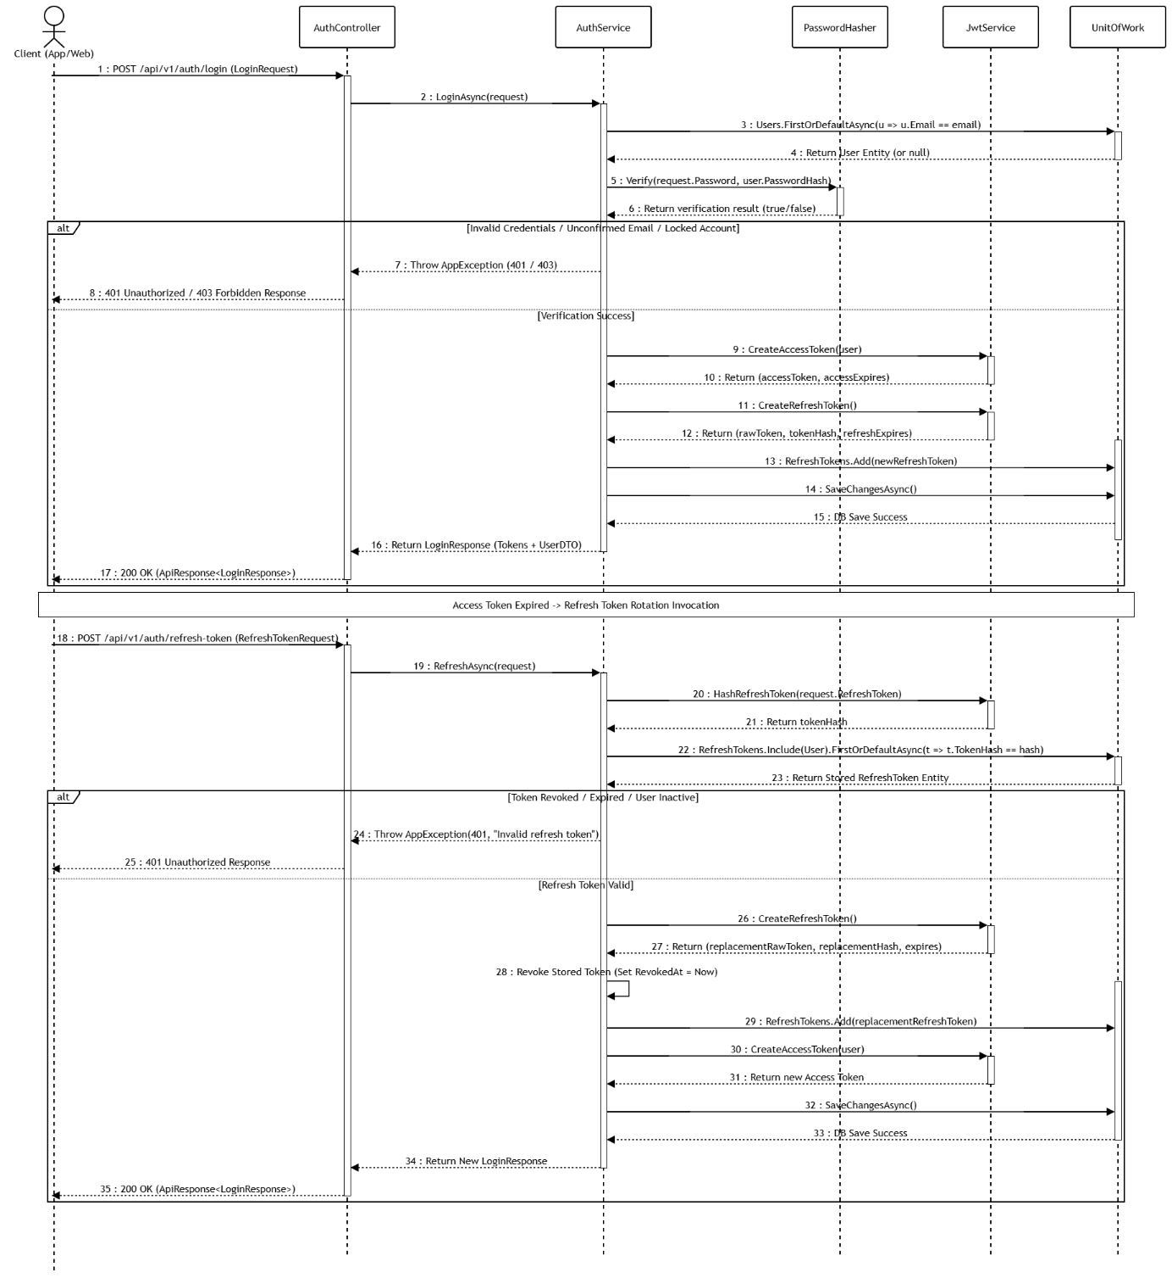

3.1.4 Sequence Diagram 3: Forgot Password & Password Reset
This sequence diagram details the process for handling forgotten passwords and account security restoration. When a user requests a password reset, the system generates a 6-digit OTP code with a 15-minute expiration and dispatches it via email. Once the user submits the valid OTP and a new password, the system updates the password hash, increments the account's token version, and revokes all active refresh tokens across all devices.
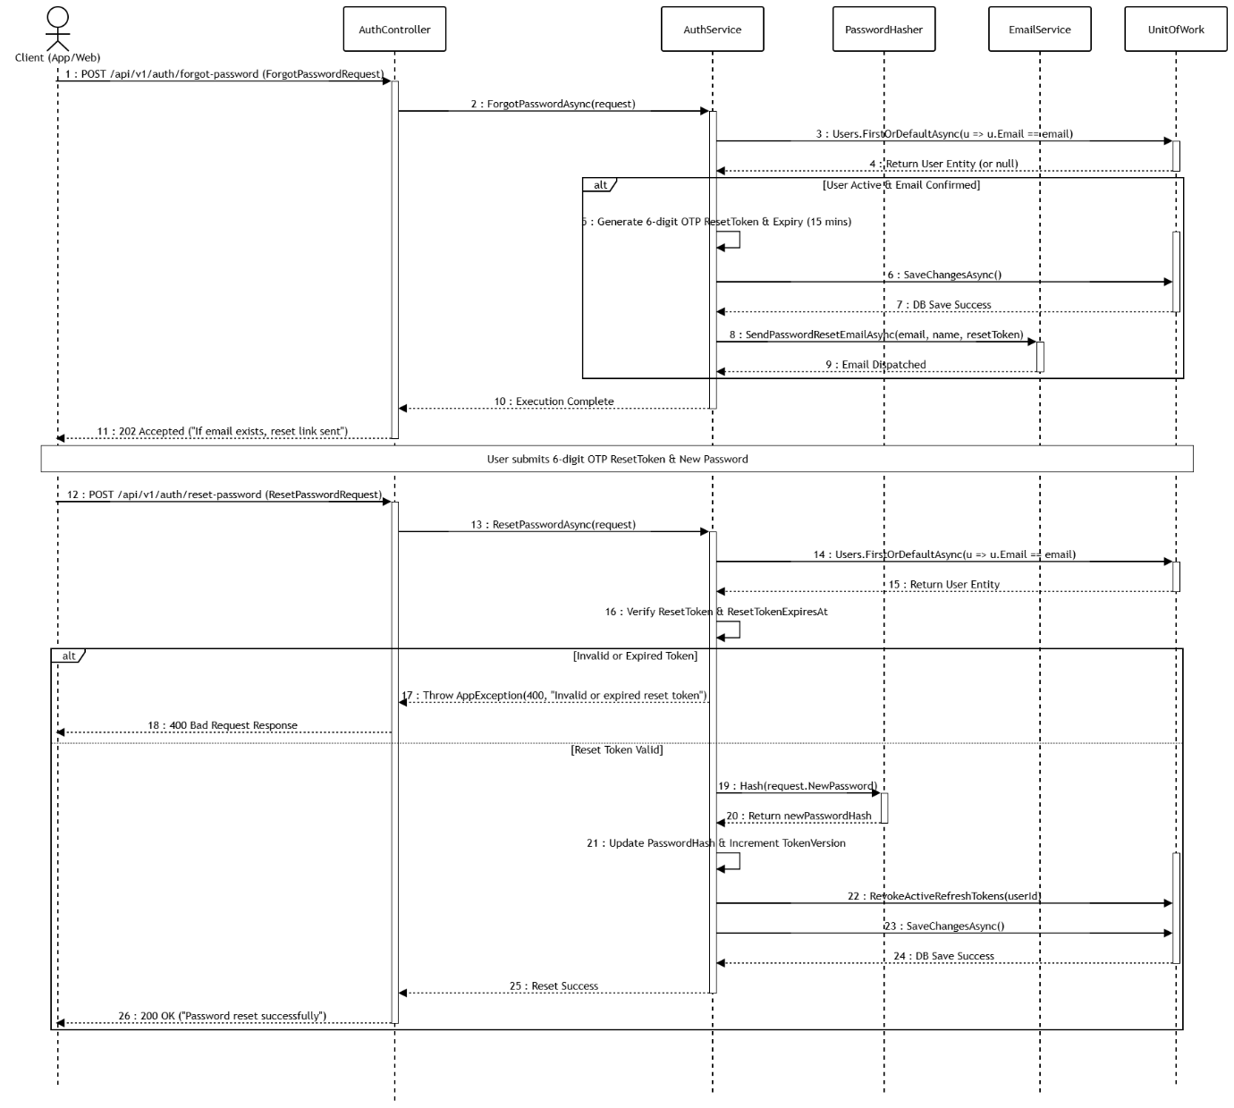

3.2 Tray Rental & Resource Reservation

3.2.1 Class Diagram
Feature 2 handles customer tray rental selection, growing capacity validation, and atomic resource reservation. To prevent capacity overbooking in concurrent environments, the system executes Serializable Transaction Locking (BeginSerializableTransactionAsync) combined with pessimistic tray locking (LockAvailableTraysAsync). Unpaid rental orders hold soil trays for a 30-minute window (PaymentWindowMinutes = 30), after which background processes (ExpireAwaitingPaymentAsync) automatically release held trays back to AVAILABLE status.
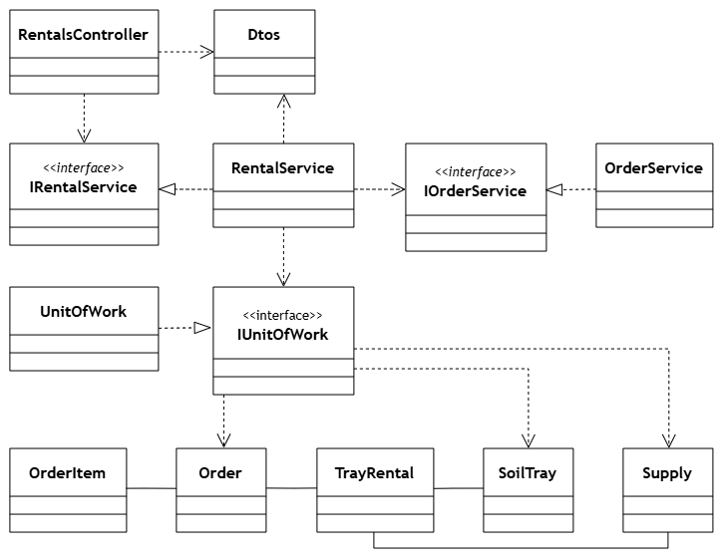
Class Specifications
No | Class / Interface Name | Layer / Type | Description
01 | RentalsController | Presentation | Handles HTTP REST API requests for creating tray rental orders, listing rental history, and fetching rental details.
02 | IRentalService | Business Service Interface | Defines core contract for tray rental workflows, capacity locking, rental pricing, and order creation.
03 | RentalService | Business Service Implementation | Implements IRentalService, executing serializable capacity lock (LockAvailableTraysAsync), pricing calculations, and transaction orchestration.
04 | IOrderService | Business Service Interface | Defines contract for order lifecycle management, status transitions, and unpaid reservation expirations.
05 | OrderService | Business Service Implementation | Implements IOrderService, managing order status updates and automated 30-minute unpaid reservation expiry (ExpireAwaitingPaymentAsync).
06 | IUnitOfWork | Data Access Interface | Defines contract for coordinating transactional boundary across multiple repositories and executing pessimistic locking.
07 | UnitOfWork | Data Access Implementation | Implements IUnitOfWork, managing relational database transactions (BeginSerializableTransactionAsync) and Entity Framework Core DbContext operations.
08 | Order | Entity | Represents the Orders database table tracking customer orders, order types (TrayRental), payment status, totals, and expiry timestamps.
09 | OrderItem | Entity | Represents itemized product lines within an order, mapping ordered seed varieties, quantities, unit prices, and subtotals.
10 | TrayRental | Entity | Represents customer rental contracts mapping assigned physical soil trays, cultivation start dates, expected harvest dates, and crop status.
11 | SoilTray | Entity | Represents physical crop trays deployed in the farm, tracking tray codes, shelf layer locations, and operational statuses (AVAILABLE, HELD, RENTED).
12 | Supply | Entity | Represents seed varieties and agricultural catalog supplies, storing rental pricing, growth durations, and minimum stock thresholds.
13 | Dtos | Data Transfer Objects | Encapsulates client request models (CreateTrayRentalRequest) and API response structures (OrderResponse, TrayRentalLineResponse).

3.2.2 Sequence Diagram 1: Tray Rental Ordering & Capacity Lock
Illustrates the order placement and pessimistic capacity reservation workflow for Feature 2. RentalService executes LockAvailableTraysAsync within a serializable transaction via UnitOfWork to lock available soil trays and prevent concurrent overbooking. Upon validation, the system creates an Order in AWAITING_PAYMENT status with a 15-minute expiration limit, marks trays as HELD, and returns a 201 Created response (or 409 Conflict if capacity is insufficient).
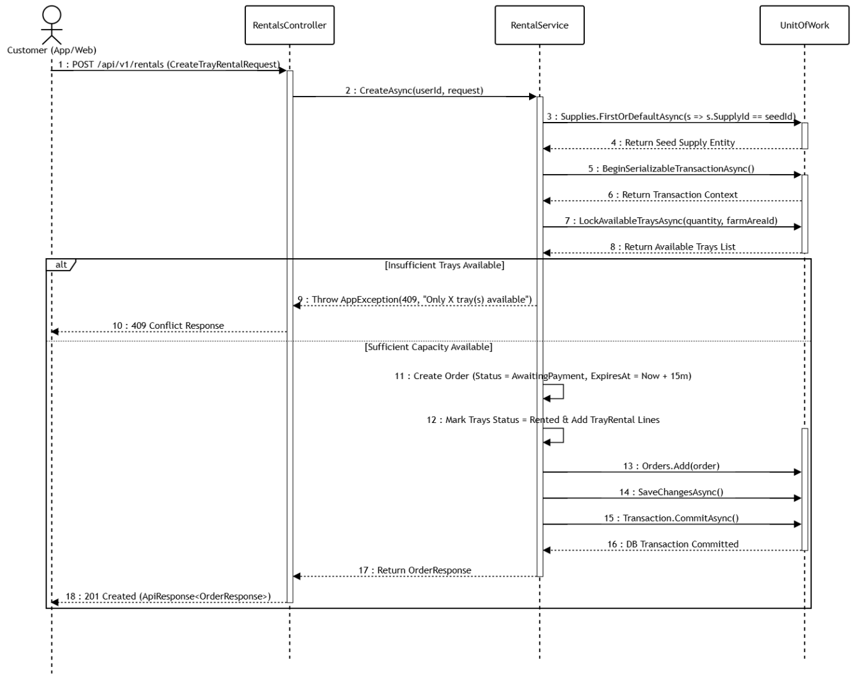

3.2.3 Sequence Diagram 2: Automatic Resource Reservation Expiry
Depicts the background cleanup process executed by a scheduled worker service (OrderExpiryWorker). The worker periodically calls OrderService.ExpireAwaitingPaymentAsync() to find unpaid orders past their 30-minute window. It then updates the order status to EXPIRED and reverts associated HELD soil trays back to AVAILABLE status within a database transaction to free up farm capacity.
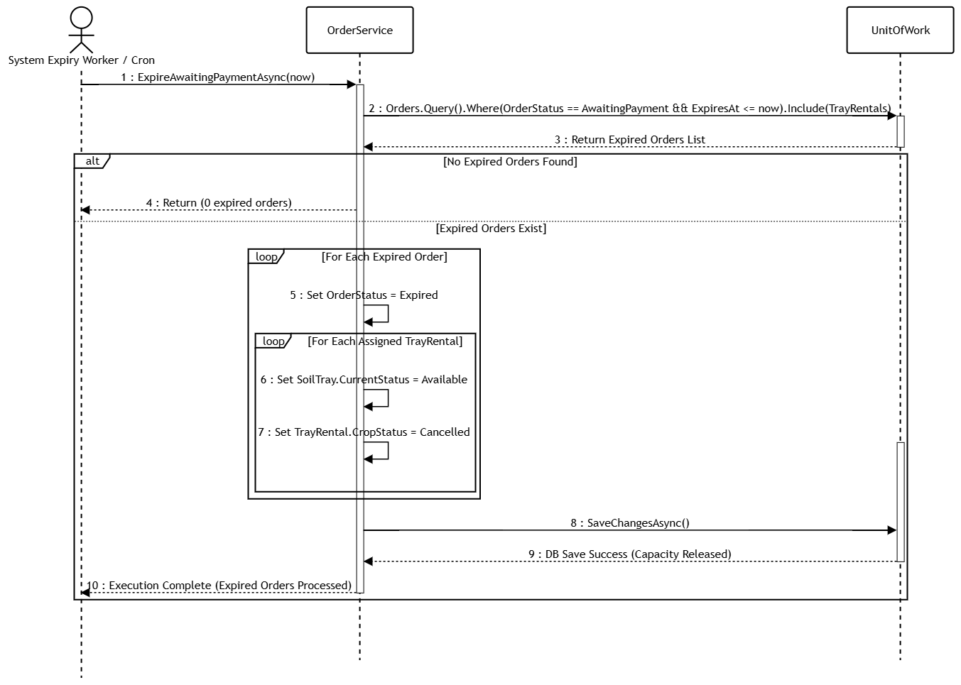

3.3 Online Payment Processing via SePay VietQR
Feature 3 manages online payment generation, dynamic VietQR creation, and automated bank transfer verification via SePay webhooks. When an order is created, the system generates a dynamic VietQR code embedding the unique order code (OrderCode) and exact total amount (TotalAmount). Upon receiving an incoming bank transfer webhook from SePay, the system validates the cryptographic signature, matches the transaction content with unpaid orders, automatically transitions order status to CONFIRMED, and prevents duplicate transaction crediting.

3.3.1 Class Diagram
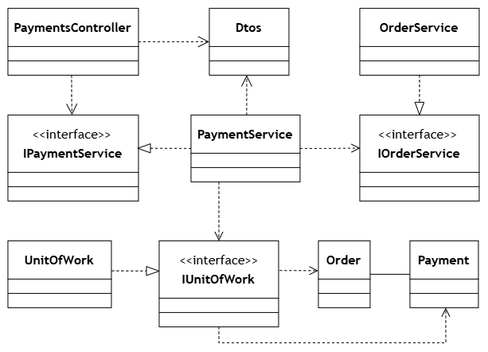
Class Specifications
No | Class / Interface Name | Layer / Type | Description
01 | PaymentsController | Presentation | Exposes REST API endpoints for VietQR generation, SePay bank transfer webhooks, and real-time payment status checks.
02 | IPaymentService | Business Service Interface | Defines core contract for VietQR generation, SePay webhook processing, signature validation, and payment status verification.
03 | PaymentService | Business Service Implementation | Implements IPaymentService, executing payment processing, VietQR image URL generation, SePay webhook cryptographic signature verification, and idempotent transaction matching.
04 | IOrderService | Business Service Interface | Defines contract for order state management, status transitions, and order fulfillment workflows.
05 | OrderService | Business Service Implementation | Implements IOrderService, updating order payment status from AWAITING_PAYMENT to CONFIRMED upon valid payment confirmation.
06 | IUnitOfWork | Data Access Interface | Defines contract for coordinating transactional boundary across repositories.
07 | UnitOfWork | Data Access Implementation | Implements IUnitOfWork, managing relational database transactions to ensure atomic updates across Orders and Payments tables.
08 | Order | Entity | Represents the Orders database table tracking customer orders, unique order codes, total amounts, and payment status.
09 | Payment | Entity | Represents the Payments database table storing bank transfer transaction codes, transfer amounts, payment gateways, and raw webhook audit logs.
10 | Dtos | Data Transfer Objects | Encapsulates request/response models for payment status (PaymentStatusResponse), VietQR payload (VietQrResponse), and SePay webhook payload (SePayWebhookPayload).

3.3.2 Sequence Diagram 1: VietQR Generation & Payment Status Polling
This sequence diagram presents the workflow for generating dynamic VietQR payment codes and client-side payment status polling. Upon requesting a QR code, the backend verifies order ownership (CustomerId == userId) and order eligibility (AwaitingPayment), constructing a dynamic VietQR image URL embedding the unique order code and total amount. After scanning the QR code, the client application polls the payment status endpoint every 3 seconds until the backend returns a Confirmed or Expired status, triggering poll termination.
3.3.4 Sequence Diagram 2: SePay Bank Transfer Webhook Processing & Order Confirmation
This sequence diagram illustrates the automated processing of incoming SePay bank transfer webhooks. Upon verifying the cryptographic webhook signature and ensuring transaction idempotency, the system matches the order code, validates the transferred amount, records the payment entity, and automatically transitions the order status to CONFIRMED within an atomic database transaction.
3.3.4 Sequence Diagram 2: SePay Bank Transfer Webhook Processing & Order Confirmation
This sequence diagram illustrates the automated processing of incoming SePay bank transfer webhooks. Upon verifying the cryptographic webhook signature and ensuring transaction idempotency, the system matches the order code, validates the transferred amount, records the payment entity, and automatically transitions the order status to CONFIRMED within an atomic database transaction.
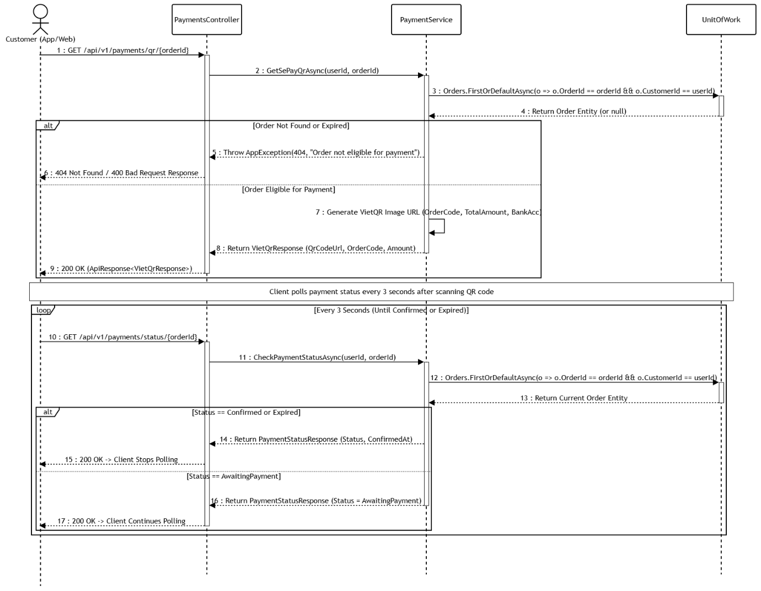

3.3.3 Sequence Diagram 2: SePay Bank Transfer Webhook Processing & Order Confirmation
This sequence diagram illustrates the automated processing of incoming SePay bank transfer webhooks. Upon verifying the cryptographic webhook signature and ensuring transaction idempotency, the system matches the order code, validates the transferred amount, records the payment entity, and automatically transitions the order status to CONFIRMED within an atomic database transaction.
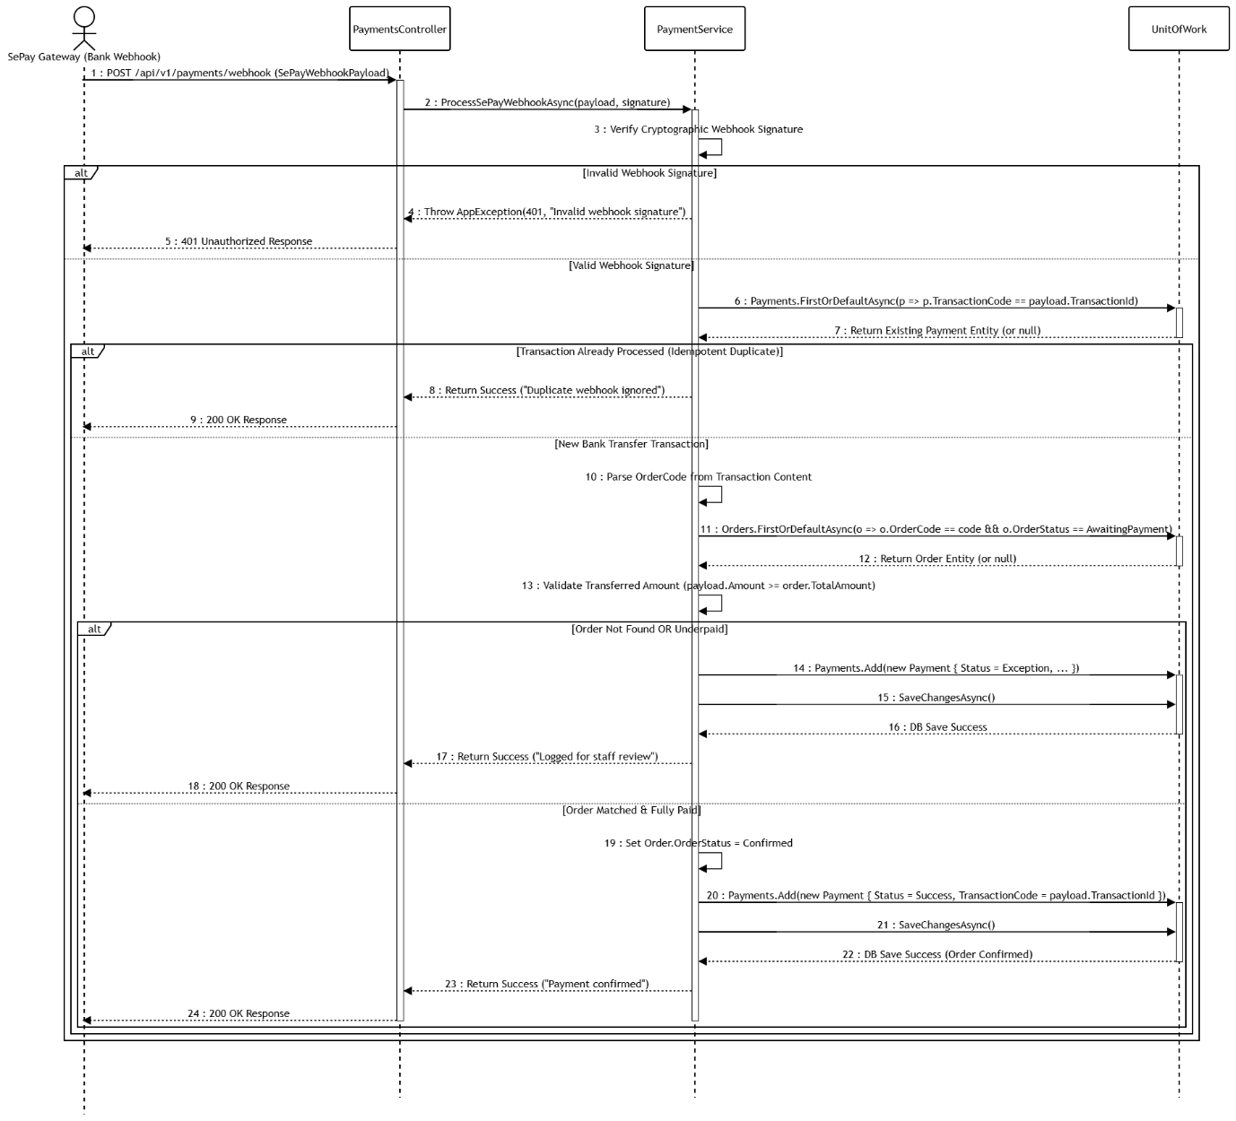

3.4 Rented Tray Monitoring & IoT Telemetry Ingestion
Feature 4 manages the ingestion of high-frequency IoT sensor telemetry and enables customers to monitor their rented microgreens trays in real time. The backend validates device API keys (X-Device-Key), checks tray assignment mappings (TrayDevices), enforces sensor value range validation, and updates device heartbeat timestamps (LastSeen). Customers can query live microclimate telemetry (temperature, air/soil humidity, light, water level) and historical trends, with automatic stale data flags (IsStale) raised if telemetry updates cease for over 5 minutes.

3.4.1 Class Diagram
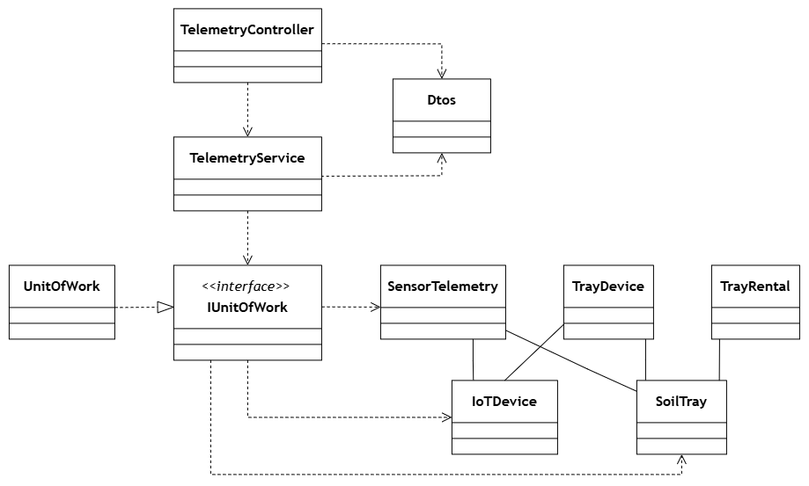
Class Specifications
No | Class / Interface Name | Layer / Type | Description
01 | TelemetryController | Presentation | Exposes REST API endpoints for device telemetry ingestion, heartbeat updates, and real-time customer/staff tray monitoring.
02 | TelemetryService | Business Service Implementation | Implements ITelemetryService, executing sensor range validation, X-Device-Key hardware verification, MessageId idempotency checks, and IsStale calculation.
03 | IUnitOfWork | Data Access Interface | Defines contract for coordinating transactional boundary across repositories.
04 | UnitOfWork | Data Access Implementation | Implements IUnitOfWork, managing relational database transactions to ensure atomic persistence across telemetry logs, device registries, and tray assignments.
05 | SensorTelemetry | Entity | Represents the SensorTelemetry database table storing high-frequency sensor measurement logs, device timestamps, and linked tray identifiers.
06 | IoTDevice | Entity | Represents the IoTDevices database table tracking hardware microcontrollers (ESP32), MAC addresses, LastSeen timestamps, and connection statuses (ONLINE, OFFLINE).
07 | TrayDevice | Entity | Represents the TrayDevices junction database table mapping active IoT sensor components and GPIO pin configurations to physical soil trays.
08 | SoilTray | Entity | Represents the SoilTrays database table deployed on farm rack tiers, tracking tray codes, shelf locations, and operational statuses (AVAILABLE, RENTED).
09 | TrayRental | Entity | Represents the TrayRentals database table mapping rented soil trays to customer accounts and active crop cultivation lifecycles.
10 | Dtos | Data Transfer Objects | Encapsulates request/response models for telemetry ingestion (TelemetryIngestRequest), heartbeat signals (HeartbeatRequest), and monitoring responses (TelemetryResponse).

3.4.2 Sequence Diagram 1: ESP32 Sensor Telemetry Ingestion
This sequence diagram illustrates the real-time ingestion workflow for microclimate telemetry sent by physical ESP32 controllers. Upon validating the device API key (X-Device-Key) and enforcing MessageId idempotency, the backend verifies device activation, validates sensor range limits, updates device LastSeen metadata, and persists the telemetry record to the database.
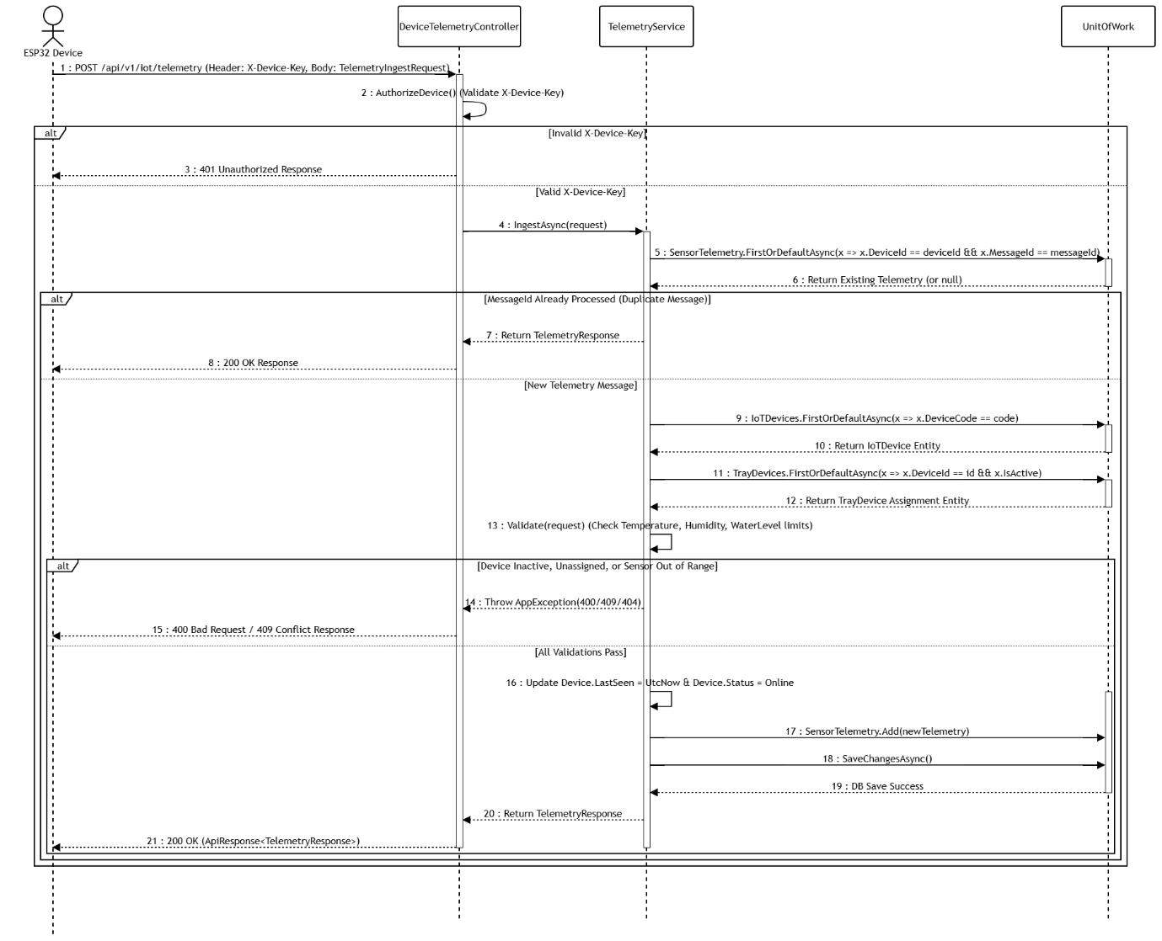

3.4.3 Sequence Diagram 2: Customer Rented Tray Telemetry Monitoring
This sequence diagram illustrates how customers remotely query real-time microclimate telemetry for their rented soil trays. Upon verifying rental contract ownership (CustomerId == userId), the backend fetches the latest sensor readings for the assigned tray and computes a stale data indicator (IsStale) if data updates cease for over 5 minutes.
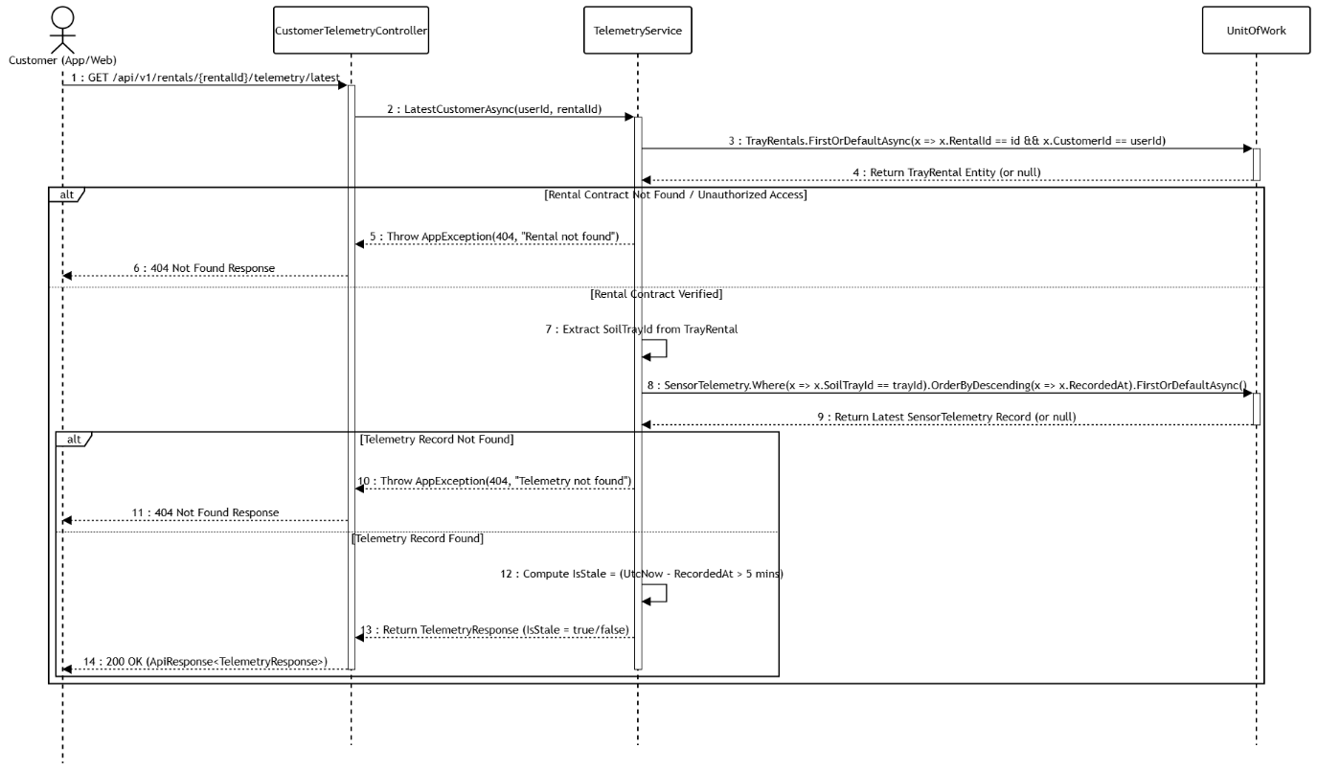

3.5 IoT Threshold Rule Engine & Manual Device Control
Feature 5 handles continuous sensor threshold evaluation and manual MQTT actuator overrides. It automatically triggers environmental controls (pumps, fans, lights) based on crop rules while enabling staff manual commands and maintaining complete execution audit logs.

3.5.1 Class Diagram
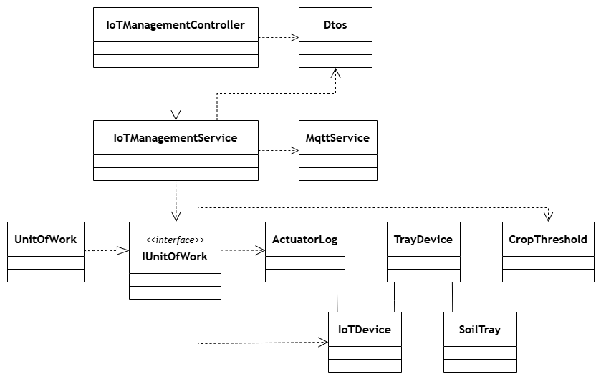
Class Specifications
No | Class / Interface Name | Layer / Type | Description
01 | IoTManagementController | Presentation | Exposes REST API endpoints for manual device control commands, override dispatches, and threshold rule queries.
02 | IoTManagementService | Business Service | Implements business logic for evaluating telemetry against threshold rules, issuing control commands, and logging actions.
03 | MqttService | Infrastructure | Manages active MQTT client broker connection, subscribing to telemetry topics, and publishing actuator control payloads to IoT devices.
04 | IUnitOfWork | Data Access Interface | Defines the interface contract for managing relational database transactions and repository access for device and threshold entities.
05 | UnitOfWork | Data Access Service | Implements IUnitOfWork to coordinate EF Core database persistence across devices, threshold rules, and execution logs.
06 | ActuatorLog | Entity | Represents the ActuatorLogs database table storing execution history, trigger sources (AUTOMATED, MANUAL), execution timestamps, and command payload statuses.
07 | CropThreshold | Entity | Represents the CropThresholds database table defining optimal min/max environmental parameters (temperature, soil moisture, air humidity, light) per crop species.
08 | IoTDevice | Entity | Represents the IoTDevices database table tracking physical hardware microcontrollers and actuators (pumps, grow lights, ventilation fans) deployed on the farm.
09 | TrayDevice | Entity | Represents the TrayDevices junction database table mapping active IoT actuators and GPIO pin configurations to physical soil trays.
10 | SoilTray | Entity | Represents the SoilTrays database table tracking farm rack trays monitored and controlled by attached IoT devices.
11 | Dtos | Data Transfer Objects | Encapsulates request/response models for manual control command dispatches (ActuatorCommandRequest), threshold rule configurations (CropThresholdRequest), and actuator log audit responses (ActuatorLogResponse).

3.5.2 Sequence Diagram 1: Automated Sensor Threshold Rule Evaluation & Actuator Trigger
This sequence diagram illustrates the automated background evaluation of incoming sensor telemetry against crop-specific threshold rules. Upon detecting an out-of-bounds parameter, the service publishes an MQTT command to activate the corresponding actuator and records an execution log for audit purposes.
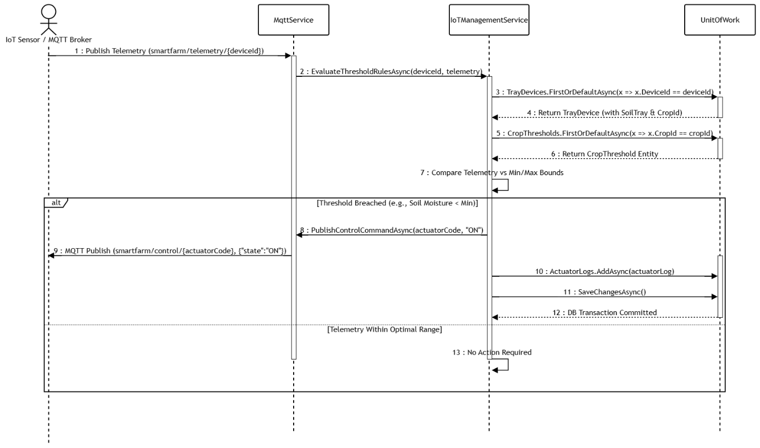

3.5.3 Sequence Diagram 2: Manual Actuator Override Command & Audit Logging
This sequence diagram illustrates the workflow for executing manual actuator control commands initiated by users via REST API. The system verifies device assignment and ownership, dispatches the control command to the physical hardware via MQTT, and records an audit log entry upon successful execution.
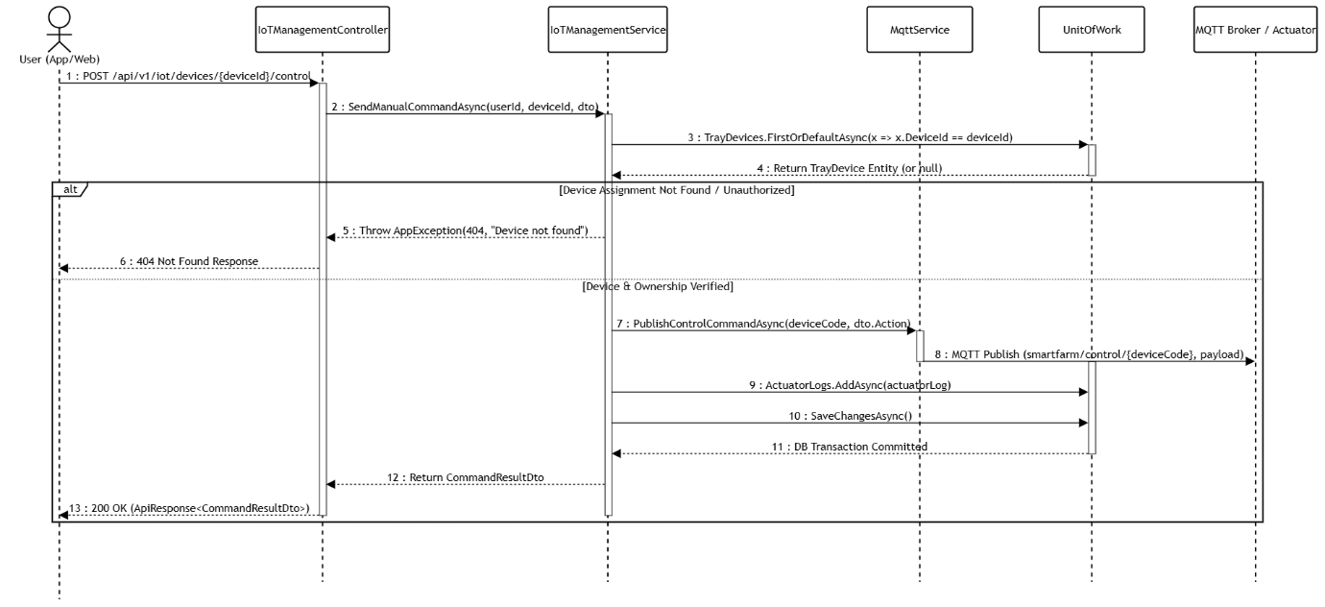

3.6 Farm Operations, Growing Cycles & Order Fulfillment
This feature manages end-to-end agricultural lifecycle operations, staff task scheduling, and harvest order fulfillment. It tracks crop growth progress across rented trays, enables farm staff to execute daily care/harvest tasks, and processes customer harvest purchase orders through structured status workflows.

3.6.1 Class Diagram
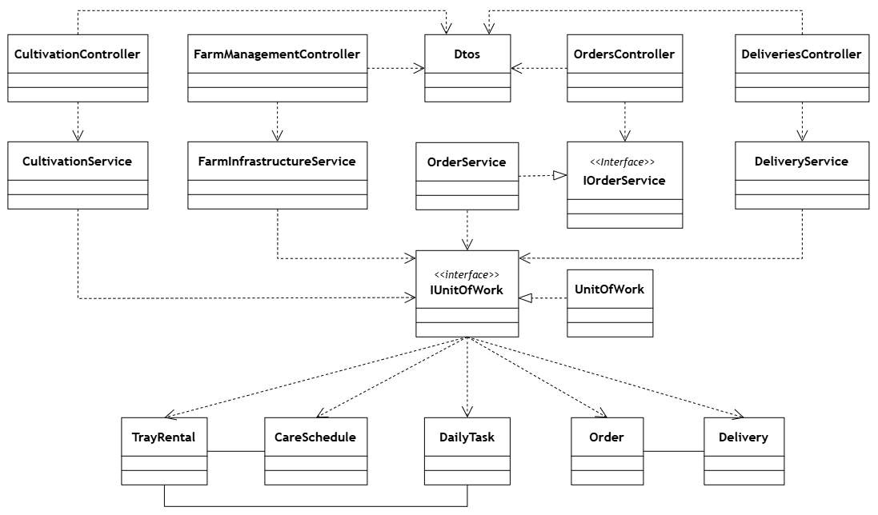
Class Specifications
No | Class / Interface Name | Layer / Type | Description
01 | CultivationController | Presentation | Exposes REST API endpoints for starting crop growing cycles, managing care schedules, recording harvest yields, and tracking staff daily tasks.
02 | FarmManagementController | Presentation | Exposes REST API endpoints for managing farm infrastructure, physical zones, rack tiers, and tray space allocations.
03 | OrdersController | Presentation | Exposes REST API endpoints for customer purchase orders and staff order lifecycle transitions.
04 | DeliveriesController | Presentation | Exposes REST API endpoints for scheduling harvest deliveries, assigning shippers, and tracking fulfillment dispatch status.
05 | CultivationService | Business Service | Implements business logic for crop cycle progression, automated daily task generation, care schedules, and harvest execution.
06 | FarmInfrastructureService | Business Service | Implements business logic for farm zone/rack/tray layout management and physical rack status updates.
07 | IOrderService | Business Service Interface | Defines core contract for purchase order management, customer order history queries, and order state transitions.
08 | OrderService | Business Service Implementation | Implements IOrderService, processing customer purchase orders, order status updates, and fulfillment workflow transitions.
09 | DeliveryService | Business Service | Implements business logic for harvest delivery scheduling, shipper assignment, and fulfillment dispatch status tracking.
10 | IUnitOfWork | Data Access Interface | Defines contract for coordinating transactional boundary across repositories.
11 | UnitOfWork | Data Access Implementation | Implements IUnitOfWork, managing relational database transactions to ensure atomic persistence across growing cycles, daily tasks, orders, and deliveries.
12 | TrayRental | Entity | Represents the TrayRentals database table tracking active crop growing cycles bound to rented physical soil trays.
13 | CareSchedule | Entity | Represents the CareSchedules database table defining day-by-day care requirements and target growth stages for crops.
14 | DailyTask | Entity | Represents the DailyTasks database table storing specific daily care tasks (watering, fertilizing, inspecting) assigned to farm staff.
15 | Order | Entity | Represents the Orders database table storing customer purchase orders for seed packets and tray rental subscriptions.
16 | Delivery | Entity | Represents the Deliveries database table tracking physical delivery dispatches for harvested produce to customer addresses.
17 | Dtos | Data Transfer Objects | Encapsulates request/response models across cultivation, farm infrastructure, order lifecycle, and delivery dispatch APIs.

3.6.2 Sequence Diagram 1: Crop Growing Cycle Initialization & Automated Staff Task Generation
This sequence diagram illustrates the workflow for initializing a crop growing cycle on an available rented tray and generating automated daily staff care tasks. The service validates tray availability and seed supply, creates a new growing cycle record (TrayRental), generates scheduled daily tasks (DailyTask) based on the crop's care template, and commits the database transaction.
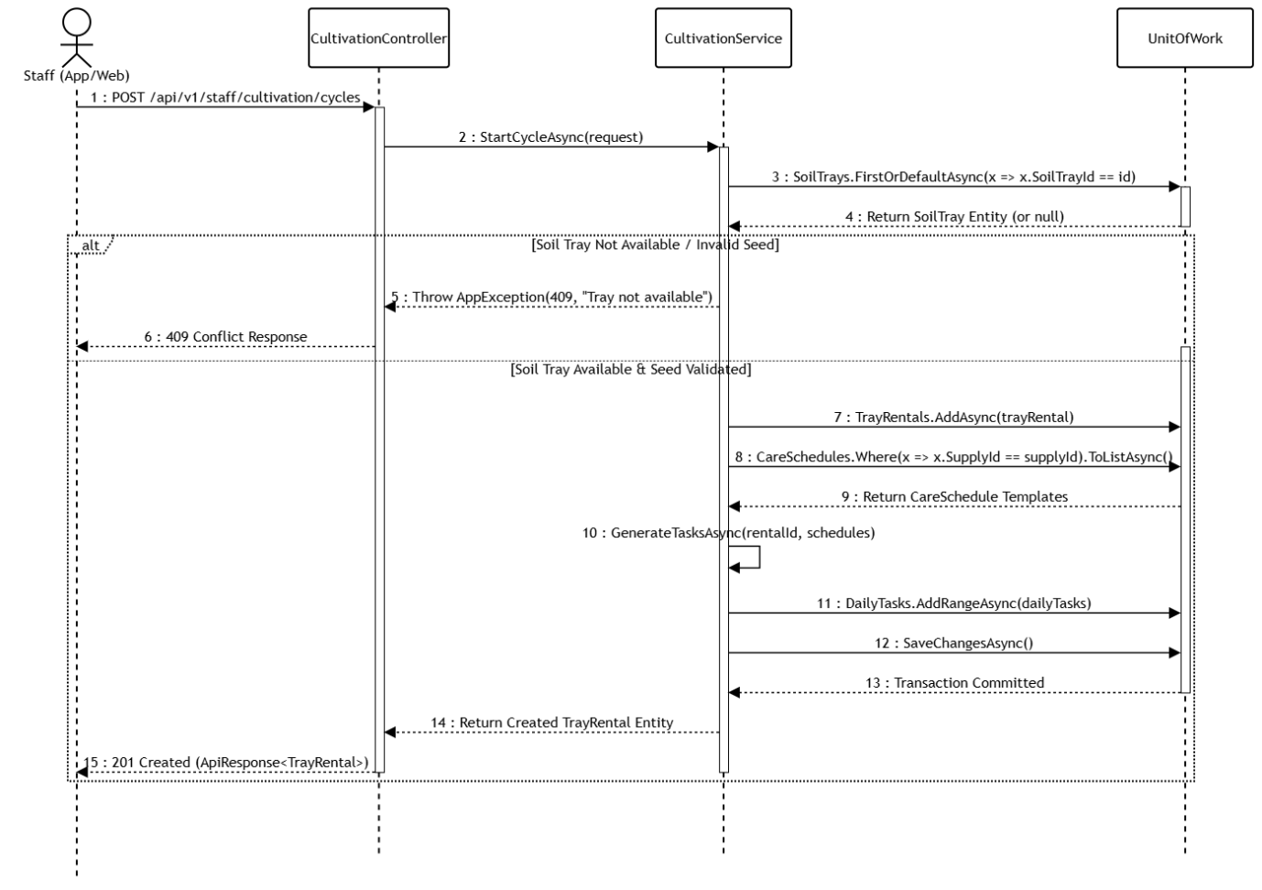

3.6.3 Sequence Diagram 2: Order Status Transition & Harvest Delivery Scheduling
This sequence diagram illustrates the workflow for updating order fulfillment status and scheduling harvest delivery dispatches. Staff transitions order states through validated status rules, while the delivery service creates physical delivery records, assigns available shippers, and commits transactional updates.


